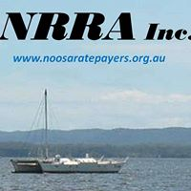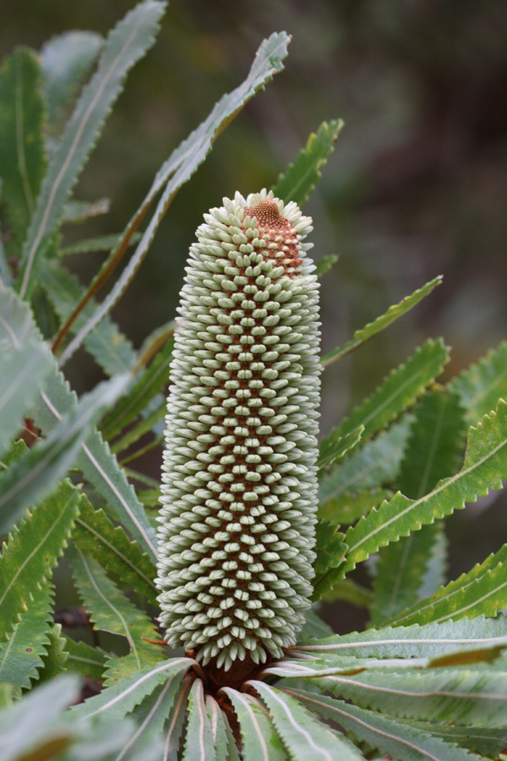
Noosa Shire Residents & Ratepayers Association

Newsletter
DECEMBER 2022 No.15

NSRRA Aims & Objectives

- To ensure that Rates and Levies are kept at the lowest practical level, consistent with an acceptable level of services to the community.
- To protect the Noosa lifestyle, which is built on a good balance between the natural and built environment – the reason most of us are here.
- To ensure that the views of the Noosa community are represented in a forceful but constructive way.
- To maintain a good relationship with Council while being respected for its well informed scrutiny of Council activities.

The Year that Was!

DECEMBER 2022 already and Summer is arriving. It has been a big year for Noosa. We STILL have an abundance of Covid 19, (Vaccinate/sanitise/distance/isolate) and other viruses, as well as serious economic issues affecting Council, business, home mortgages, and health and well being. This is on top of our tourism, transport pressures on residents, and finding employees and affordable rental accommodation all which remain a major issue. Shortages of staff have adversely affected Council as well resulting in delays in a range of services. This is not only a local problem but one that is widespread nationally.
NSRRA public meetings remain suspended because of COVID 19 affecting venues and risk to participants. NSRRA Management Committee meets regularly to make submissions and address a range of ongoing issues. Some of us have been directly impacted by Covid with ongoing health concerns. Lingering medical symptoms are being reported more and more.
We urge everyone to take health precautions and stay safe!

What’s Happening?

Council Meetings
Don’t forget, Council Agendas with reports and Minutes are listed on the Noosa Council website. ‘noosa.qld.gov.au’ These are a valuable source of information as to how the Noosa Shire and Council are managed on our behalf. You can also watch Noosa Council meetings on the internet live streaming on ‘Youtube’ - although audio remains poor.

Go to www.noosa.qld.gov.au then follow the menus to ‘council’ and ‘meetings’. Council has an online consultation system that is a great source of information with a great facility for feedback. Go to noosa.qld.gov.au Website, and under ‘quicklinks’ and ‘your say noosa’, find the current consultative projects and a wealth of reports. A real opportunity exists to contribute and get involved.

Noosa Council Corporate Plan 2023 - 2028

Council is currently preparing the Corporate Plan 2023-2028, which when adopted, provides the framework for council’s decisions about policy, programs and resources.
A series of community feedback sessions played a vital part in developing Noosa’s new strategic plan for the future of the shire.
Council is reviewing and considering the submissions with the intention of having a new draft for review in late January 2023.

Noosa Plan 2020 remains our best protection from changes to policy resulting in weakened regulation which would adversely affect residents’ amenity. Strong enforcement is required The push for Noosa to take significant increases in population as SEQ grows and is also a source of pressure on our lifestyle, already under threat from vested interests.

On 18 February 2020 QLD Govt advised Council that Noosa Plan 2020 (NP2020) was approved subject to a condition to monitor the provisions relating to short term accommodation, tourism and housing supply for a 2 years from 31 July 2020.
The Minister’s conditional approval required that:
The council must:
1. Monitor the provisions relating to short-term accommodation, tourism and housing
supply considering the outcomes sought across the residential zones.
and
2. Submit a report to the Minister on completion of the monitoring process with any proposed amendments.

A Noosa Council report – ‘STRA Monitoring report’ – has been prepared by Council in response to State Govt requirements re implementation of Noosa Plan. We are currently working through the details.

NSRRA made a submission to Qld Govt relating to the Review resulting in a response from the Deputy Premier. (see attached)

The Noosa River Plan is currently being work-shopped by a stakeholder group comprising Marine Safety Queensland, NSC and a number of stakeholders. They are investigating various issues such as derelicts, live-aboards, mooring/anchoring, and various other issues. Progress is very slow and there is a lack of practical improvement. Our representative on the group has withdrawn owing to a lack of progress.
Some improvements will require legislative change. A stakeholder submission to NSC and State Govt is (possibly) due for release for public consultation soon.

Noosa Shire Housing Strategy
Noosa Council has adopted a ‘Noosa Housing Strategy 2022’ policy at a recent meeting, following a ‘Housing Needs Survey’ and consultation. This 18page document details a range of initiatives designed to help secure affordable housing for workers and others as a result of planning failure, an explosion of Short Term Rental Accomodation, Covid 19 and other State and National problems. Some of these problems are years in the making. We are reviewing the contents and have serious concerns about the potential impacts on our small Shire. More later.

Local Law - short stay letting and home hosted accommodation.
Noosa Council adopted a new local law for short stay rental accommodation on 1 February 2022. The new local law will regulate the ongoing operation of short stay letting and home hosted accommodation and manage the impacts on permanent residents and guest safety

There is an indisputable need for STA regulatory framework to address the impact on residents from the disruption of quiet suburban settings and associated anti-social guest behaviour. Despite a pushback campaign from ‘business’ interests, the law has been put in place. It’s not perfect but close. It is making a difference. Approvals are ongoing – slowly.

Remember, Noosa Council 24hr Complaints Hotline is 53296466 to report issues. These businesses are required to display their registration number.

Kin Kin Quarry Issue – Ongoing issues continue with dangerous quarry trucks operating in high volume on very poor quality roads. Roads from Sheppersons Lane Kin Kin to Pomona and other routes are in a continuous state of repair. The people of the hinterland are currently awaiting a Court decision. This ongoing situation has resulted in serious safety and wellness concerns in the community.

The Future!

Noosa Matters
To keep up to date with information that matters to those who are concerned about some of the things happening in local politics, we urge you to go to noosamatters.com.au.
A wealth of knowledge and hard hitting commentary analyses information otherwise not easily found. For Facebook fans, search for NoosaMatters.

ELECTION 24
Next Council Election is in March 2024. Already, indications are that this will be an important election with our community values under threat from both inside and outside our boundaries. As a small Shire we need community involvement to protect the way of life we enjoy from development and politics.

Your support and community involvement is very important. Consider what is happening around us and be aware and involved. We live in Paradise with a lot to protect.

Our areas of interest for 2022/23 include:
- Protection of our Biosphere, our lifestyle amenity and the integrity of the Noosa Plan.
- A financially transparent and responsible NSC Council protecting residents.
- Management of traffic, parking and congestion issues adversely affecting local residents across Noosa.
- Control of STA growth and it’s impact on Residents.
- A housing strategy that focuses on State Govt leadership for affordable, and social housing and not on swamping Noosa Shire with high density living.
- For Translink - The large, noisy and frequently poorly utilised diesel buses still attract complaints. We have ONE Electric bus on the network - even though electric buses abound worldwide.

Membership of NSRRA –

If you are not yet a member, and wish to join, or are renewing your membership, email us at noosaratepayers@gmail.com and we’ll send you our Membership Form. Membership process and form have recently been changed. Membership fees for 2022/23 are $10 per person.

If you have any issues or local problems, contact us and we will try to help.

‘Noosa Residents & Ratepayers’ on Facebook and website is: www.noosaratepayers.org.au

Best Wishes for a Merry Christmas and a better 2023! Stay Safe!

Adrian Williams
President



